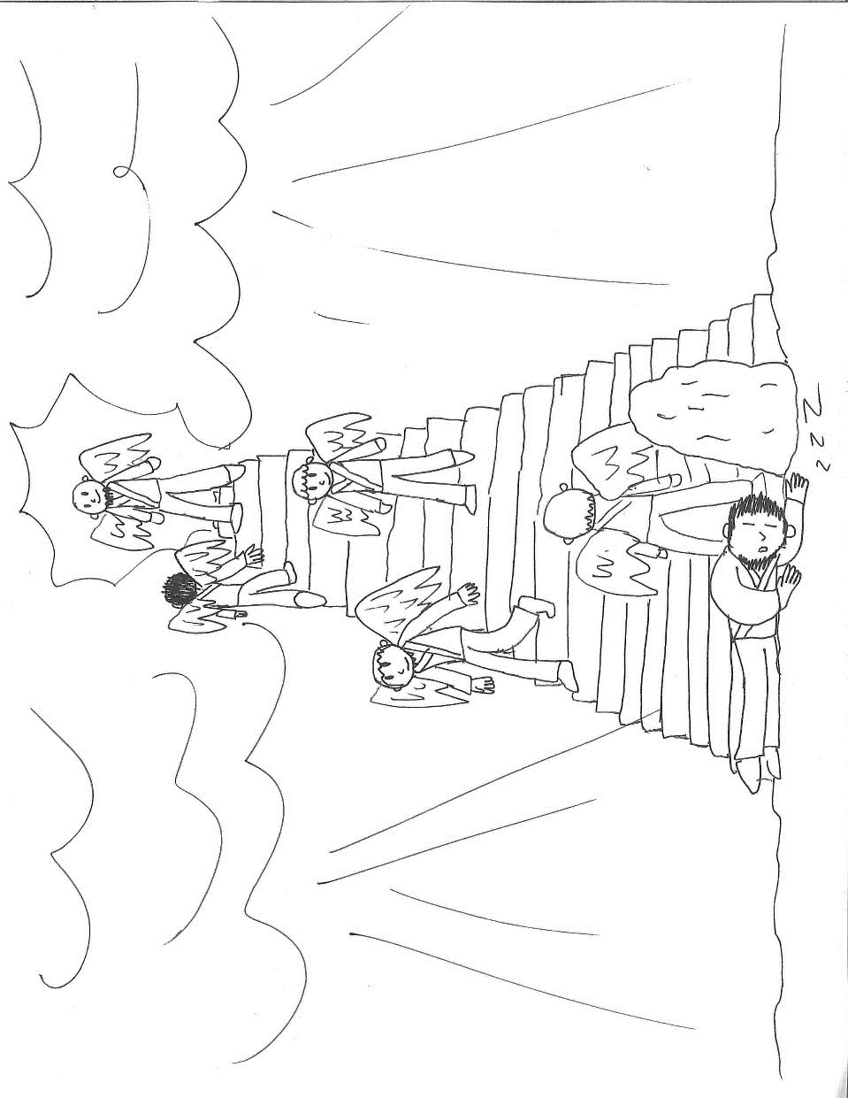
5th Week after Pentecost
Drawing courtesy of Sam Squires
Thursday, June 21, and Sunday, July 24, 2018
Bethel Lutheran Church & Preschool
5110 Grand Avenue, Gurnee, Illinois 60031 – (847) 244-9647
Pastor Ben Squires
Cell phone: 224-419-5519 or email: pastor@bethelgurnee.org
Katrina Johns, Equipping Coordinator
Direct line: 224-623-0800 or email: katrina@bethelgurnee.org
Website: www.BethelGurnee.org
Divine Service (Bethel Setting)
This service is adapted from the Divine Services in Lutheran Service Book.

Summer Worship Schedule
Thursday 6:30 p.m. & Sunday 9:00 a.m.
Holy Communion: 1st, 3rd, 5th Sundays and the Thursday prior
Becky Lanzito & Karen Leicht - Organists, Ann Souza - Music Director,
Mandi Diver – Choir/New Music Accompanist
____________________________________________________________________________________________________________________________________________________________________________________________
Welcome to our visitors
We are pleased you chose to be with us in worship today, and pray the Lord blesses you as he has blessed us with your presence. Our goal is to help people find the right place for them to hear God’s word and serve His mission. We’d love to support you in that spiritual journey. Please take a moment to complete an attendance card and place it in the Offering plate or give to an usher. This card will help us connect with you.
Nursery
We have two rooms available for your use. When the service is in the sanctuary, the nursery is down the hall just past the restrooms. If the service is held in the gym, the nursery is in the youth room at the far end of the gym.
____________________________________________________________________________________________________________________________________________________________________________________________

Serving Today
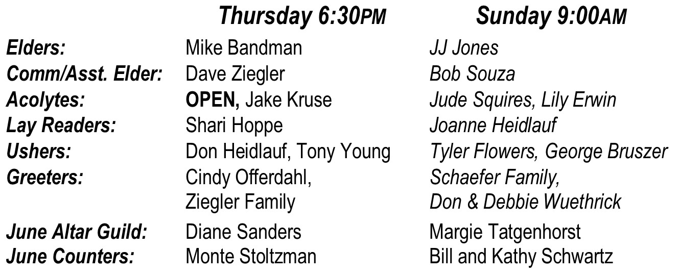
____________________________________________________________________________________________________________________________________________________________________________________________
Altar Flowers are Provided by:
Dave and Cheryl Ross in celebration of their wedding anniversary.

Opening Hymn God Himself Is Present LSB 907
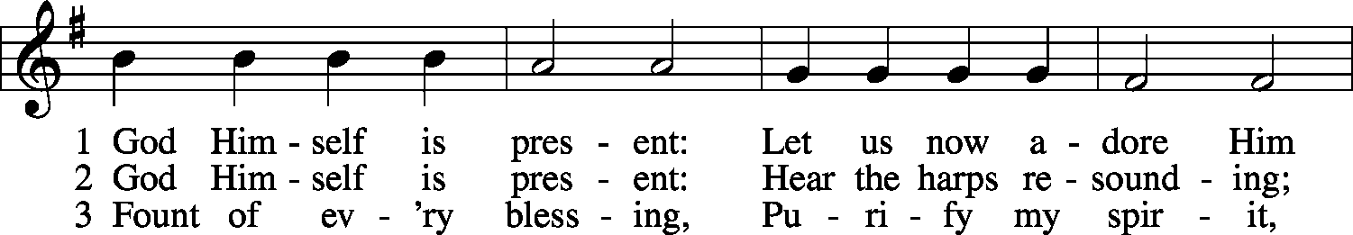
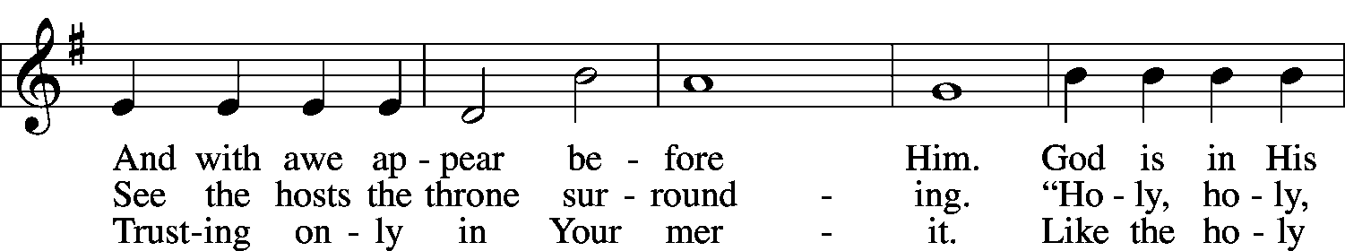
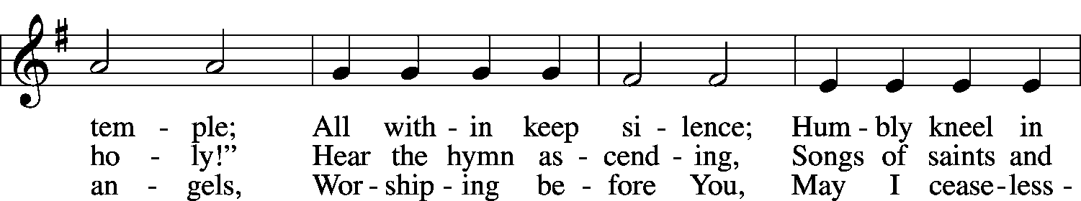
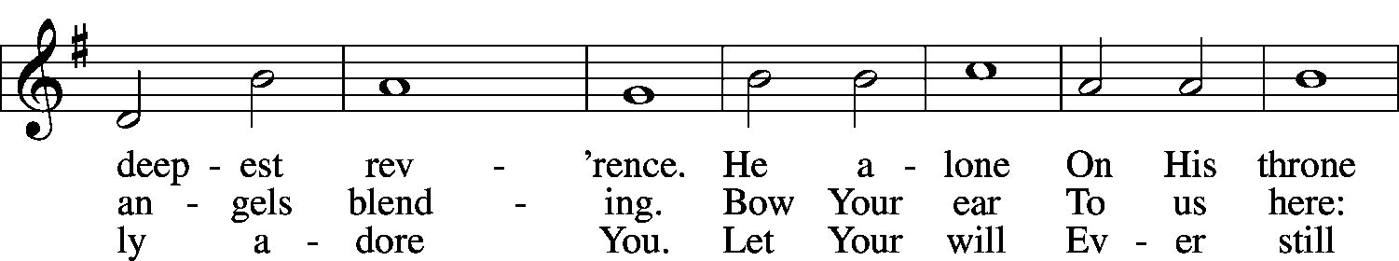
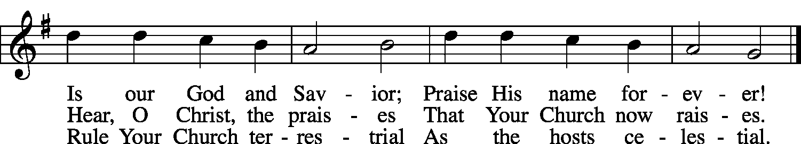
Invocation, Exhortation, and Confession of Sins
P: In the Name of the Father and of the Son and of the Holy Spirit.
C: Amen.
P: Beloved in the Lord! Let us draw near with a true heart and confess our sins unto God our Father, beseeching Him in the name of our Lord Jesus Christ to grant us forgiveness…Our help is in the name of the Lord,
C: who made heaven and earth.
P: I said, I will confess my transgressions unto the Lord,
C: and You forgave the iniquity of my sin.
P: Since we are gathered to hear God’s Word and call upon Him in prayer and praise, let us first consider our unworthiness and confess before God and one another that we have sinned in thought, word, and deed, and that we cannot free ourselves from our sinful condition. Together as His people let us take refuge in the infinite mercy of God, our heavenly Father, seeking His grace for the sake of Christ, and saying: God, be merciful to me, a sinner.
C: Almighty God, have mercy upon us, forgive us our sins,
and lead us to everlasting life. Amen.
P: Almighty God, merciful Father, in Holy Baptism You declared us to be Your children and gathered us into Your one, holy Church, in which You daily and richly forgive us our sins and grant us new life through Your Spirit. Be in our midst, enliven our faith, and graciously receive our prayer and praise; through Your Son, Jesus Christ, our Lord. C: Amen.
Absolution (Forgiveness)
P: Upon this your confession, I, by virtue of my office, as a called and ordained servant of the Word, announce the grace of God unto all of you, and in the stead and by the command of my Lord Jesus Christ I forgive you all your sins in the name of the Father and of the Son and of the Holy Spirit.
C: Amen.

Thanksgiving Verse By Grace I’m Saved LSB 566 st. 3
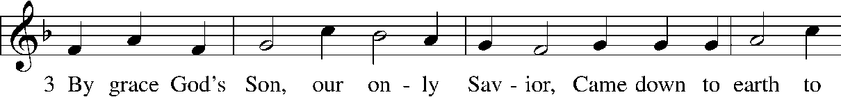
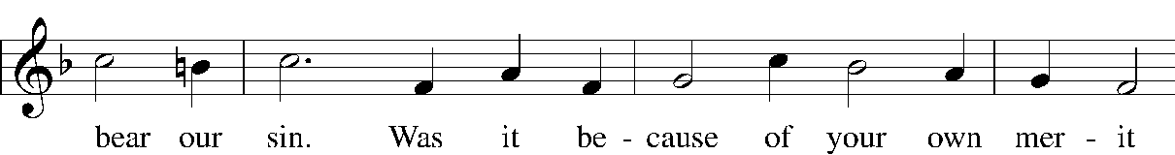
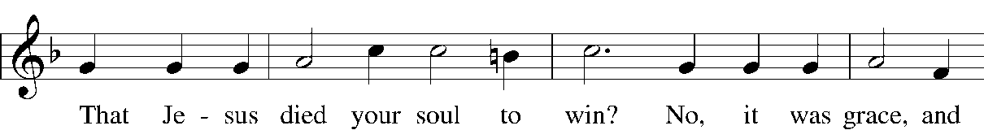
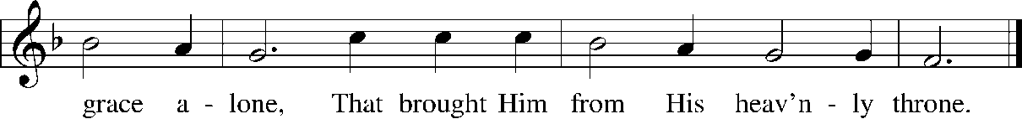
Kyrie (Lord, Have Mercy)
P: In peace let us pray to the Lord.
C: Lord, have mercy.
P: For the peace from above and for our salvation, let us pray to the Lord.
C: Lord, have mercy.
P: For the peace of the whole world, for the well-being of the Church of God,
and for the unity of all, let us pray to the Lord.
C: Lord, have mercy.
P: For this holy house, and for all who offer here their worship and praise,
let us pray to the Lord.
C: Lord, have mercy.
P: Help, save, comfort, and defend us, gracious Lord.
C: Amen.
Greeting and Collect (Prayer of the Day)
P: The Lord be with you.
C: And also with you.
P: Let us pray. God of our fathers and mothers—of all the generations who have come before us—holy is Your name. We gather in Your presence with praise and thanksgiving for the faithful love You have shown toward Your people, for the many blessings You have given to us. Your promises are eternal, and they are backed by the honor of Your name. Thank you for Your faithful presence among us, even when we are not fully aware of it. Continue to reveal Yourself to us. Open our eyes to see You here among us; open our ears to hear Your Word. For surely, You are with us in this place; through Jesus Christ, our Lord, who lives and reigns with You and the Holy Spirit, one God, now and forever.
C: Amen.
Confession of Faith Apostles’ Creed
I believe in God, the Father Almighty, maker of heaven and earth.—And in Jesus Christ, His only Son, our Lord, who was conceived by the Holy Spirit, born of the virgin Mary, suffered under Pontius Pilate, was crucified, died and was buried. He descended into hell. The third day He rose again from the dead. He ascended into heaven and sits at the right hand of God the Father Almighty. From thence He will come to judge the living and the dead.—I believe in the Holy Spirit, the holy Christian Church, the communion of saints, the forgiveness of sins, the resurrection of the body, and the life everlasting. Amen.
Old Testament Reading for the 5th Week after Pentecost Job 38:1–11(ESV)
¹Then the Lord answered Job out of the whirlwind and said:
²“Who is this that darkens counsel by words without knowledge?
³Dress for action like a man; I will question you, and you make it known to me.
⁴“Where were you when I laid the foundation of the earth?
Tell me, if you have understanding.
⁵Who determined its measurements—surely you know!
Or who stretched the line upon it?
⁶On what were its bases sunk, or who laid its cornerstone,
⁷when the morning stars sang together
and all the sons of God shouted for joy?
⁸“Or who shut in the sea with doors when it burst out from the womb,
⁹when I made clouds its garment and thick darkness its swaddling band,
¹⁰and prescribed limits for it and set bars and doors,
¹¹and said, ‘Thus far shall you come, and no farther,
and here shall your proud waves be stayed’?”
L: This is the Word of the Lord.
C: Thanks be to God.
Acknowledgements
Portions of this service is adapted from the Lutheran Service Book, Divine Service, Setting Three.
Used by permission: LSB Hymn License .NET, no. 000013448.
Created by Lutheran Service Builder © 2006 Concordia Publishing House.
Unless otherwise indicated, all scripture quotations are from The Holy Bible, English Standard Version,
copyright © 2001 by Crossway Bibles, a division of Good News Publishers.
Used by permission. All rights reserved.

In Worship,
we read the story from Know the Bible Now, pages 36-37—
“Jacob’s Dream”

Hymn of the Day How Firm a Foundation LSB 728
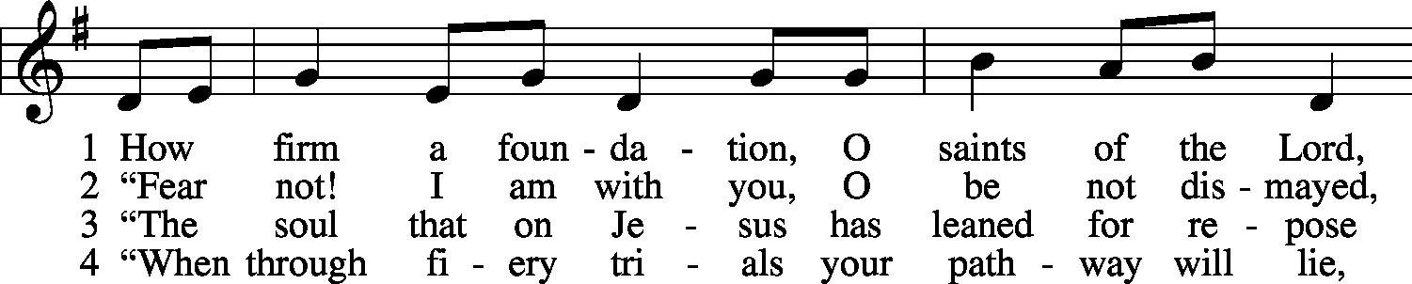
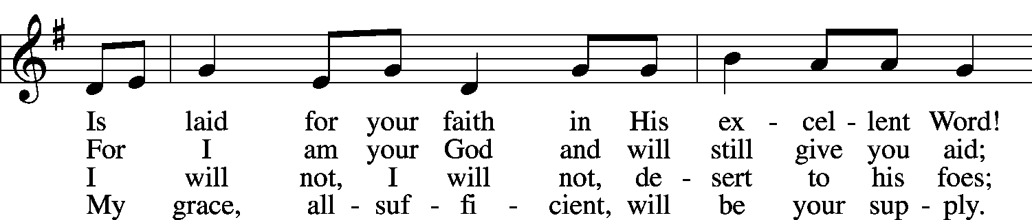
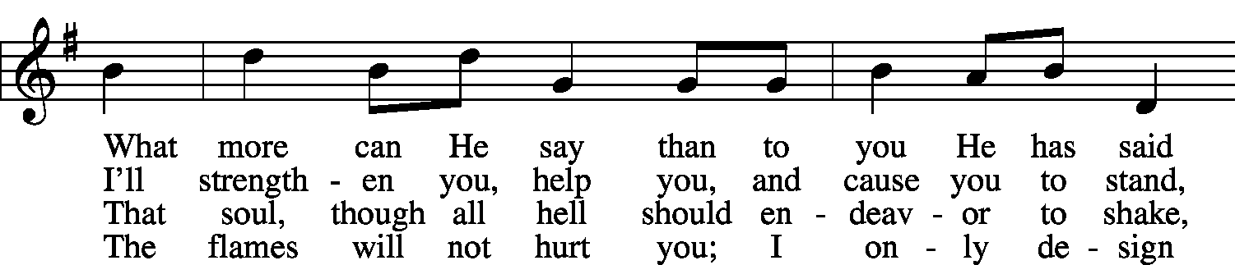
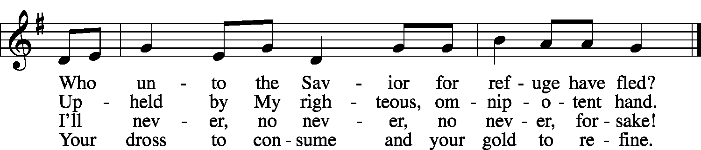

5 “Throughout all their lifetime My people will prove
My sov’reign, eternal, unchangeable love;
And then, when gray hairs will their temples adorn,
Like lambs they will still in My bosom be borne.”

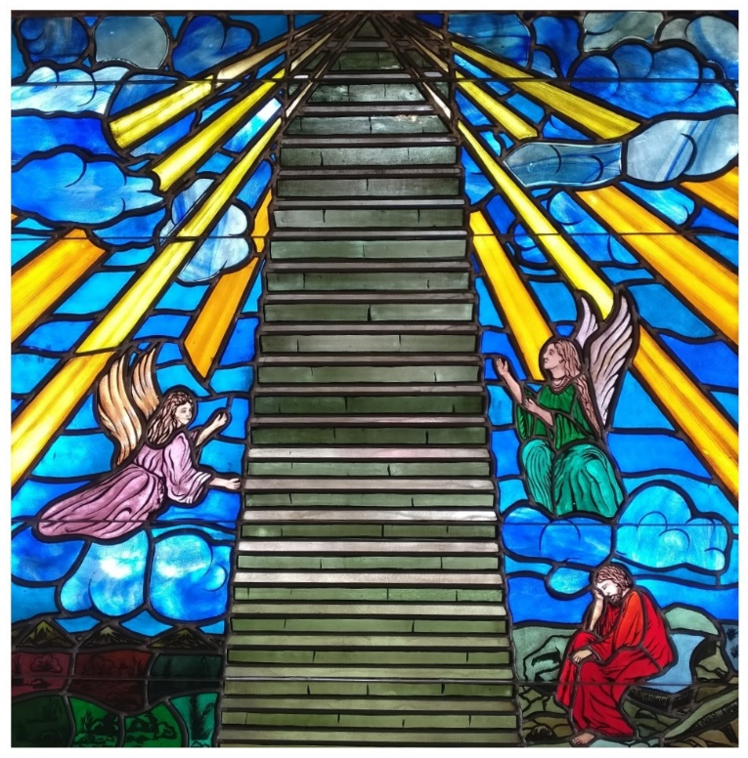
Sermon
Genesis 28:10-22
¹⁰Jacob left Beersheba and went toward Haran. ¹¹And he came to a certain place and stayed there that night, because the sun had set. Taking one of the stones of the place, he put it under his head and lay down in that place to sleep.
¹²And he dreamed, and behold, there was a ladder set up on the earth, and the top of it reached to heaven. And behold, the angels of God were ascending and descending on it!
¹³And behold, the Lord stood above it and said, “I am the Lord, the God of Abraham your father and the God of Isaac. The land on which you lie I will give to you and to your offspring. ¹⁴Your offspring shall be like the dust of the earth, and you shall spread abroad to the west and to the east and to the north and to the south, and in you and your offspring shall all the families of the earth be blessed. ¹⁵Behold, I am with you and will keep you wherever you go, and will bring you back to this land. For I will not leave you until I have done what I have promised you.”
Jacob's Dream at Bethel @ Bethel's Narthex
¹⁶Then Jacob awoke from his sleep and said, “Surely the Lord is in this place, and I did not know it.” ¹⁷And he was afraid and said, “How awesome is this place! This is none other than the house of God, and this is the gate of heaven.”
¹⁸So early in the morning Jacob took the stone that he had put under his head and set it up for a pillar and poured oil on the top of it. ¹⁹He called the name of that place Bethel, but the name of the city was Luz at the first. ²⁰Then Jacob made a vow, saying, “If God will be with me and will keep me in this way that I go, and will give me bread to eat and clothing to wear, ²¹so that I come again to my father’s house in peace, then the Lord shall be my God, ²²and this stone, which I have set up for a pillar, shall be God’s house. And of all that you give me I will give a full tenth to you.”
Offering & Prayer Requests
In addition to the prayer requests already received, Pastor will pause here to see if there are additional requests. Prayers can be thanksgivings, joy, requests for yourself, or requests for others.
Offertory Take My Life and Let It Be LSB 783
**Today’s “Favorite Hymn” selection**
(Sung as the Offerings are brought forward and placed on the altar)
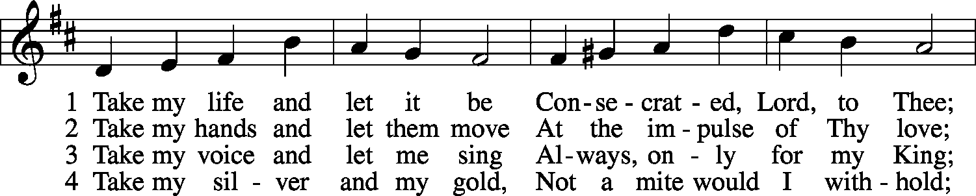
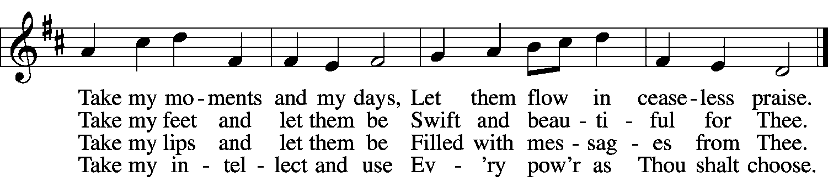

5 Take my will and make it Thine,
It shall be no longer mine;
Take my heart, it is Thine own,
It shall be Thy royal throne.
6 Take my love, my Lord, I pour
At Thy feet its treasure store;
Take myself, and I will be
Ever, only, all for Thee.

Prayers
The Lord’s Prayer
P: Lord, remember us in Your kingdom, and teach us to pray:
All: Our Father who art in heaven, hallowed be Thy name, Thy kingdom come, Thy will be done on earth as it is in heaven. Give us this day our daily bread; and forgive us our trespasses as we forgive those who trespass against us; and lead us not into temptation, but deliver us from evil. For Thine is the kingdom and the power and the glory forever and ever. Amen.

The Lord’s Benediction (Blessing) to Jacob and to Us
P: God the Father says to you: “I am the Lord, the God of Abraham your father and the God of Isaac. In you and your offspring shall all the families of the earth be blessed. Behold, I am with you and will keep you wherever you go. For I will not leave you until I have done what I have promised you.”
C: Amen.

Closing Hymn Alleluia, Song of Gladness LSB 417
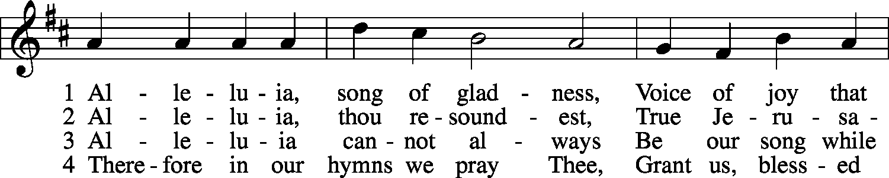
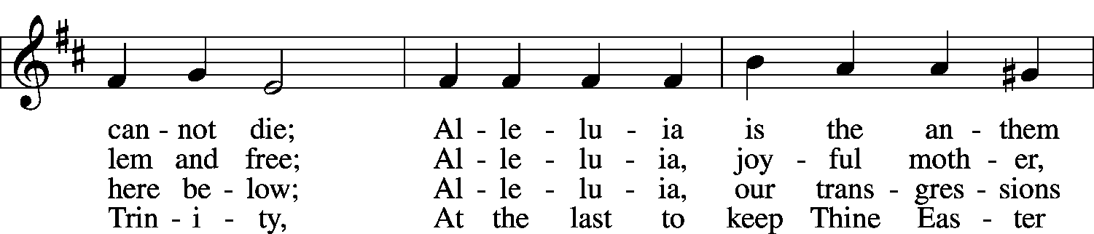
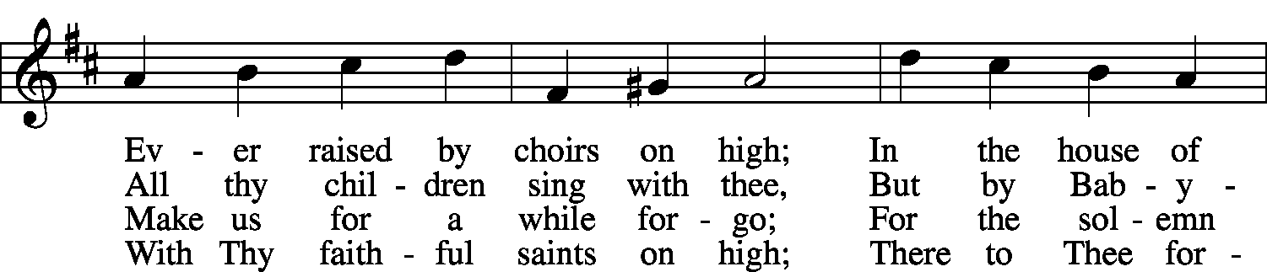
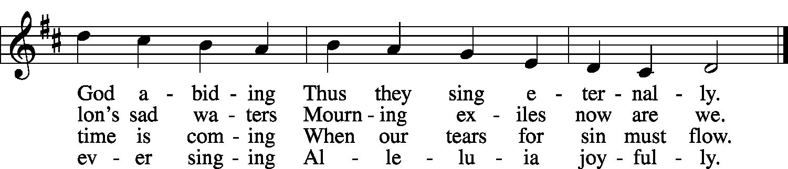

Announcements

In Today’s Prayers
If you have something you’d like added,
please go to one of the Prayer Stands,
write down your request, & put in the plastic rack.
In our weekly Worship Prayers, we lift up praises, thanksgivings, requests, and concerns to our Lord. In order to help us pray to God about the wholeness of our lives in the world, we have a schedule for when we will focus on specific areas for prayer. Any immediate needs will always take priority, but in general, we will follow this schedule. Please note that this means on the 2nd and 4th Sundays of the month, Pastor will speak the names of everyone on our health concerns list, but on other Sundays, this will be lifted up only as a general prayer for health and healing.

4th Sunday of the Month
Local Churches
Lutheran Church—Missouri Synod Circuit (area) churches:
Beautiful Savior-Antioch, Faith-Lake Forest, Lord of Glory-Grayslake,
Redeemer-Waukegan, Prince of Peace-Waukegan
GO! Together partner churches in Gurnee:
Gurnee Community, Joy!, Lakeland, Life, Village, New Abbey,
Immanuel, La Viña, Epicenter, House of Prayer, New Hope
Waukegan Churches participating in the Mosaic Learning Community
For more info, go to http://mosaic.tiu.edu
Christian Neighbors, CityReach, First Presbyterian, Iglesia Emanuel, Journey, Living Waters Cathedral, New Abbey, Shiloh Baptist, Sign of the Dove, Waukegan Baptist Bible, Waukegan Christian Faith Fellowship, Waukegan Community Church
Congregation Goal: Missional Living
Living as disciples among our neighborhoods, workplaces,
schools, families, friends, and daily living

