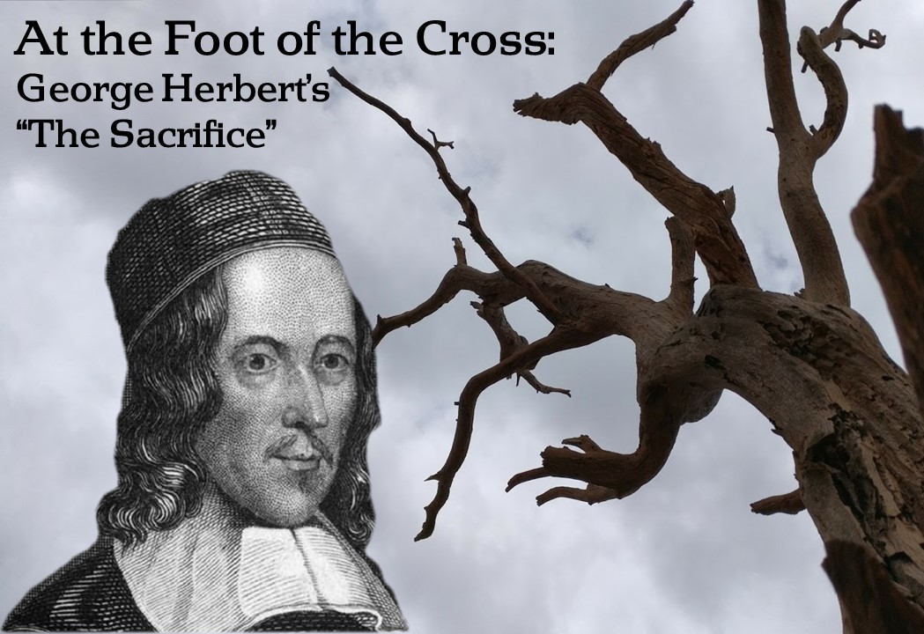
Wednesday, March 27, 2019

Bethel Lutheran Church & Preschool
5110 Grand Avenue, Gurnee, Illinois 60031 – (847) 244-9647
Pastor Ben Squires
Cell phone: 224-419-5519 or email: pastor@bethelgurnee.org
Katrina Johns, Equipping Coordinator
Direct line: 224-623-0800 or email: katrina@bethelgurnee.org
Website: www.BethelGurnee.org

Worship Schedule
Sundays 8:00 a.m. & 10:45 a.m.
Holy Communion: 1st, 3rd, 5th Sunday of the month
Becky Lanzito & Karen Leicht - Organists, Ann Souza - Music Director,
Mandi Diver – Choir/New Music Accompanist
___________________________________________________________________________________________________________________________________________________________________________________________________________________________________________________________________________________________________________________________________________________________________________________________
Welcome to our Visitors
We are pleased you chose to be with us in worship today, and pray the Lord blesses you as he has blessed us with your presence. Our goal is to help people find the right place for them to hear God’s word and serve His mission. We’d love to support you in that spiritual journey. Please take a moment to complete an attendance card and place it in the Offering plate or give to an usher. This card will help us connect with you.
Holy Communion
The Lord’s Supper is celebrated according to the Lutheran Confessions based on the teaching Jesus gave his disciples and us that he is truly present in this meal. Confident that our sins are forgiven, we experience our oneness with him and each other as he gathers us at his table. His true body and blood, given and shed for us, we share in this meal as he invites in Matthew 26:26-28, “Take and eat; this is My Body … This is My Blood…” Baptized Christians sharing these beliefs are invited to receive Communion. All others are invited to the altar rail for a blessing. Wine can be taken by common chalice, individual cup, or by dipping your wafer into the chalice. Please address questions to the Elders or the Pastor. Non-alcoholic wine is in purple-colored cups.
Nursery
We have two rooms available for your use. When the service is in the sanctuary, the nursery is down the hall just past the restrooms. If the service is held in the gym, the nursery is in the youth room at the far end of the gym.
___________________________________________________________________________________________________________________________________________________________________________________________________________________________________________________________________________________________________________________________________________________________________________________________
Serving Today
Elder: Dave Ziegler
Asst Elder: OPEN
Acolytes: Brooke Ratzburg
Ushers: OPEN, OPEN
Lay Readers: Nathan Faitsch, Tim Faitsch
Greeters: Randy & Linda Gifford

A Liturgy of Doubt and Hope
Worship in a traditional order drawing on along with words of doubt and hope
from Scripture, poets, and writers.

Opening Hymn Hail, Thou Once Despised Jesus LSB 531
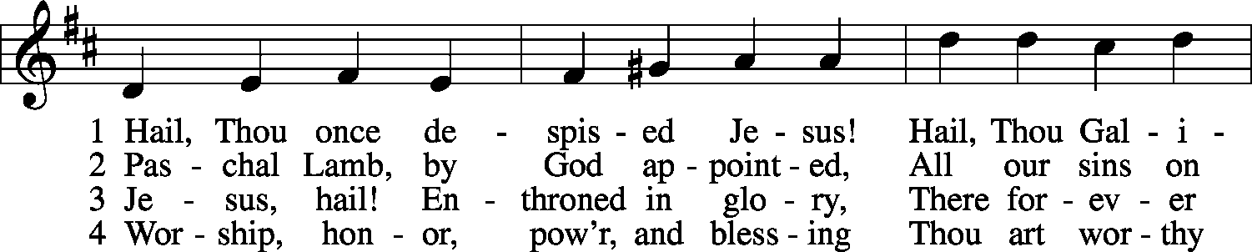
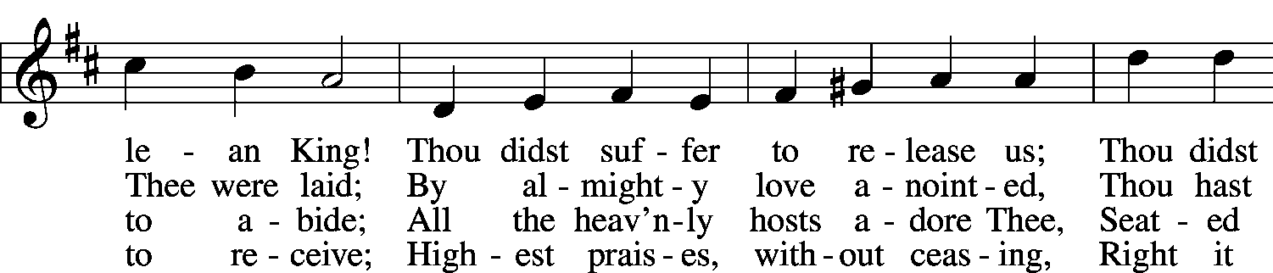
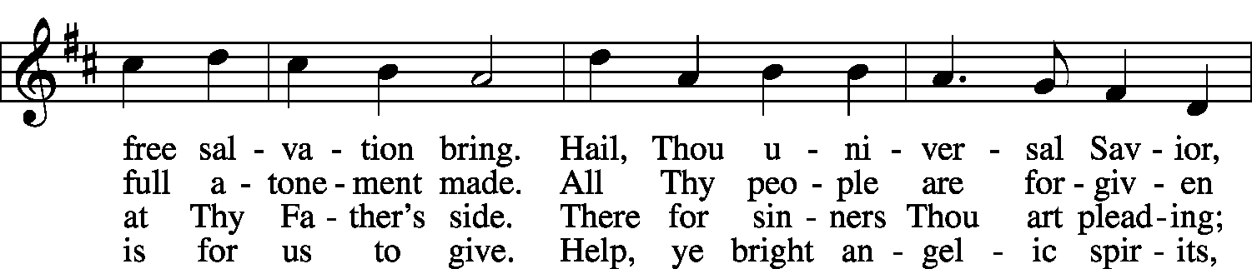
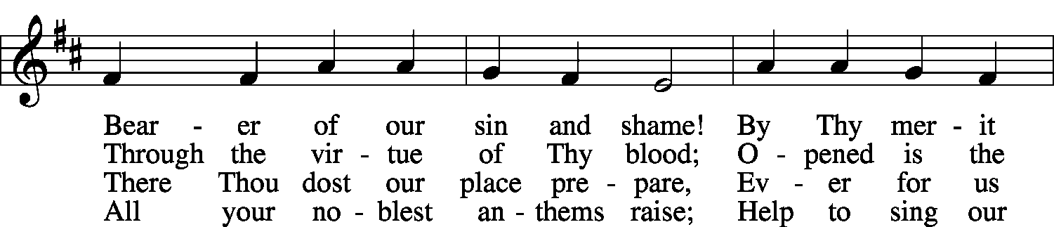
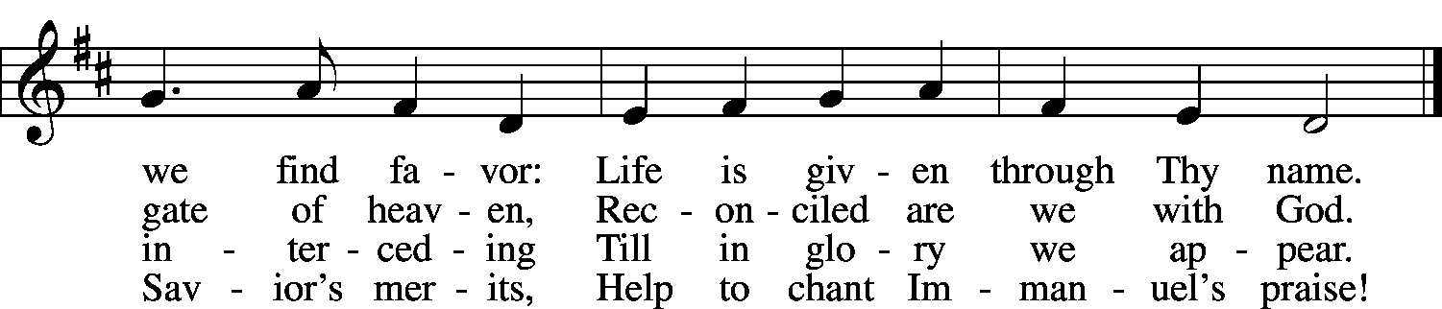

Invocation Jude 1-2,20-22,25
P: In the name of the Father and of the + Son and of the Holy Spirit. C: Amen.
P: We come to be built up in our most holy faith,
building one another up through the Word of God.
God the Father calls on us to have compassion on one another:
C: “Have mercy on those who doubt.”
Jesus is able to keep us from stumbling
and to present us blameless before the presence of his glory with great joy. Amen.
Confession of Sins Based on “Emmanuel” by Aaron Niequist
P: Can we just admit together that we’re not fine?
C: Because I’m not fine, and you’re not fine.
P: Can we just admit together that we’re afraid?
C: Because I’m afraid, and you’re afraid.
P: Can we just admit together that we have doubts?
C: Because I have doubts, and you have doubts.
P: Can we just admit together that we’re not free?
C: Because I’m not free, and I want to be.
P: If you’re not free, then call out to God with me:
C: Emmanuel, God with us today,
We humbly call out Your Name:
Emmanuel,
As near as our need,
As close as the air that we breathe,
Emmanuel.
Lord, have mercy.
P: Can we just admit together that we have failed?
C: Because I have failed, and you have failed.
P: Can we just admit that our hands aren’t clean?
C: And our hearts aren’t clean, and they’ll never be.
P: Until we’re freed, and mercy sings.
C: Emmanuel, God with us today,
We desperately cling to Your Name:
Emmanuel,
As near as our need,
As close as the air that we breathe.
Emmanuel. Lord, have mercy. Amen.
Absolution (Forgiveness) Based on liturgy by Bernie Seter and “Emmanuel” by Aaron Niequist
P: Almighty God, the Father of our Lord Jesus Christ, does not desire the death of sinners, which means He does not desire your death. But rather He calls you to turn from your wicked ways and find life in the life of Christ. He has had mercy upon you. He graciously forgives your sins through the death and resurrection of Your Lord Jesus Christ. He strengthens you by the power of the Holy Spirit to amend your sinful lives according to His will, and will keep you in His grace until that day when He will take you to be with Him for eternity. Therefore, as a called and ordained servant of the Word, in His stead and by His command, I forgive you all your sins in the name of the Father and of the Son and of the Holy Spirit.
C: Amen.
Emmanuel,
God with us today,
In thanksgiving we praise Your Name:
Emmanuel,
Who came near so we are freed,
As close as the Word that we hear.
Emmanuel.
The Lord has had mercy on us.
P: Now we can admit together that we’ve failed,
C: Because I am forgiven, and you are forgiven.
P: Now we can admit together that our hands aren’t clean,
C: Because Jesus made me clean, and He made you clean.
P: If you’re now free, then call out to God with me:
C: Emmanuel,
God with us today,
In thanksgiving we praise Your Name:
Emmanuel.
The Lord has had mercy on us. Amen.
Collect (Prayer of the Day)
P: Let us pray. O God, whose glory it is always to have mercy, be gracious to all who have gone astray from Your ways and bring them again with penitent hearts and steadfast faith to embrace and hold fast the unchangeable truth of Your Word; through Jesus Christ, Your Son, our Lord, who lives and reigns with You and the Holy Spirit, one God, now and forever. C: Amen.
Gospel Reading for Tonight’s “Sacrifice” Stanzas (ESV)
¹³Pilate then called together the chief priests and the rulers and the people, ¹⁴and said to them, “You brought me this man as one who was misleading the people. And after examining him before you, behold, I did not find this man guilty of any of your charges against him. ¹⁵Neither did Herod, for he sent him back to us. Look, nothing deserving death has been done by him. ¹⁶I will therefore punish and release him.”
Luke 23:13–23
¹⁸But they all cried out together, “Away with this man, and release to us Barabbas”— ¹⁹a man who had been thrown into prison for an insurrection started in the city and for murder. ²⁰Pilate addressed them once more, desiring to release Jesus, ²¹but they kept shouting, “Crucify, crucify him!” ²²A third time he said to them, “Why, what evil has he done? I have found in him no guilt deserving death. I will therefore punish and release him.” ²³But they were urgent, demanding with loud cries that he should be crucified. And their voices prevailed.
⁹[Pilate] entered his headquarters again and said to Jesus, “Where are you from?” But Jesus gave him no answer. ¹⁰So Pilate said to him, “You will not speak to me? Do you not know that I have authority to release you and authority to crucify you?” ¹¹Jesus answered him, “You would have no authority over me at all unless it had been given you from above. Therefore he who delivered me over to you has the greater sin.”
John 19:10–16
¹²From then on Pilate sought to release him, but the Jews cried out, “If you release this man, you are not Caesar’s friend. Everyone who makes himself a king opposes Caesar.” ¹³So when Pilate heard these words, he brought Jesus out and sat down on the judgment seat at a place called The Stone Pavement, and in Aramaic Gabbatha. ¹⁴Now it was the day of Preparation of the Passover. It was about the sixth hour. He said to the Jews, “Behold your King!” ¹⁵They cried out, “Away with him, away with him, crucify him!” Pilate said to them, “Shall I crucify your King?” The chief priests answered, “We have no king but Caesar.”
²⁴So when Pilate saw that he was gaining nothing, but rather that a riot was beginning, he took water and washed his hands before the crowd, saying, “I am innocent of this man’s blood; see to it yourselves.” ²⁵And all the people answered, “His blood be on us and on our children!” ²⁶Then he released for them Barabbas, and having scourged Jesus, delivered him to be crucified.
Matthew 27:15–26
P: This is the Gospel of the Lord.
C: Thanks be to God.
Readings for Other References in Tonight’s “Sacrifice” Stanzas (ESV)
Philippians 4:4–7
⁴Rejoice in the Lord always; again I will say, Rejoice. ⁵Let your reasonableness be known to everyone. The Lord is at hand; ⁶do not be anxious about anything, but in everything by prayer and supplication with thanksgiving let your requests be made known to God. ⁷And the peace of God, which surpasses all understanding, will guard your hearts and your minds in Christ Jesus.
1 Corinthians 13:12
¹²For now we see in a mirror dimly, but then face to face. Now I know in part; then I shall know fully, even as I have been fully known.
Psalm 78:12–16
¹²In the sight of their fathers he performed wonders
in the land of Egypt, in the fields of Zoan.
¹³He divided the sea and let them pass through it,
and made the waters stand like a heap.
¹⁴In the daytime he led them with a cloud,
and all the night with a fiery light.
¹⁵He split rocks in the wilderness
and gave them drink abundantly as from the deep.
¹⁶He made streams come out of the rock
and caused waters to flow down like rivers.
1 Corinthians 10:1–5
¹I want you to know, brothers, that our fathers were all under the cloud, and all passed through the sea, ²and all were baptized into Moses in the cloud and in the sea, ³and all ate the same spiritual food, ⁴and all drank the same spiritual drink. For they drank from the spiritual Rock that followed them, and the Rock was Christ. ⁵Nevertheless, with most of them God was not pleased, for they were overthrown in the wilderness.
L: this is the Word of the Lord.
C: Thanks be to God.

Hymn of the Day Lamb of God LSB 550
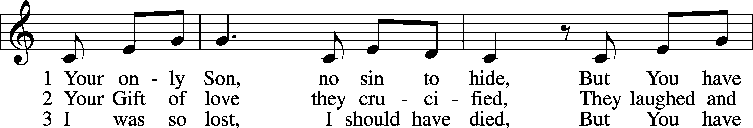
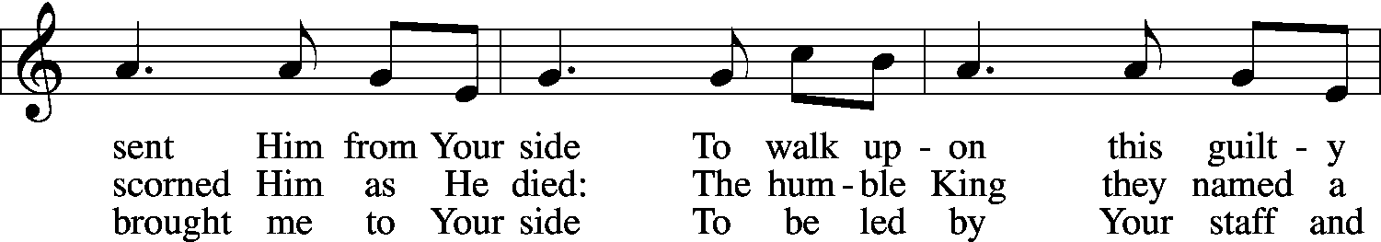
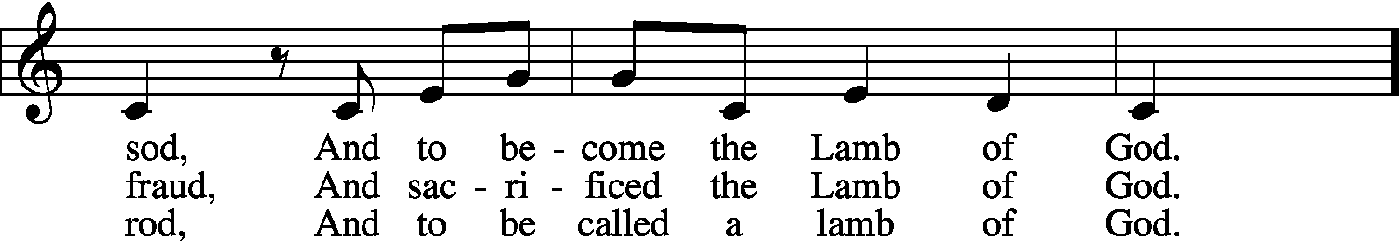
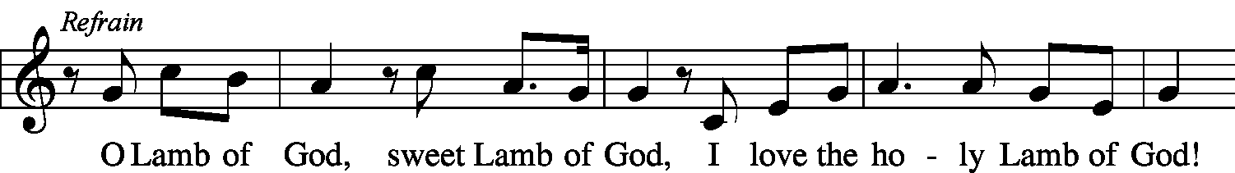
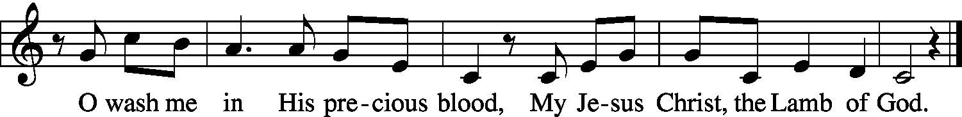

© 1985 Straightway Music; admin. EMI . Used by permission: LSB Hymn License .NET, no. 100013448.

Sermon “See How Spite Cankers Things” (see handout)

Confession of Faith (adapted from the Apostles’ Creed) First Nations Version
Our Father and Creator, the One Above Us All,
made all things in the world above and the earth below.
Jesus, his special born Son,
was fathered by the Holy Spirit
and was born into this world through a virgin named Mary.
He suffered under Pontius Pilate, a ruler of the Roman people,
who had him nailed to a tree pole, the cross, where he bled to death.
He was buried and then went down to the world of the dead.
On the third day he came back to life, never to die again.
He returned to his Father in the world above
and sat down at his powerful right hand.
One day he will return to this earth to make the final decision
about the eternity of the living and the dead.
After he went to the world above,
Jesus sent the Holy Spirit to us from the Father,
to live in and through us.
There is only one holy and world-wide group of believers in Jesus
—a Sacred Family called his Church.
All of the Holy Spirit’s holy people sit together equally in this Family
and share his Sacred Food at his table.
He has forgiven us and set us free from all of our broken ways,
and all who trust in him, even though they cross over to death,
will be brought back to life again,
to a life that will never end. Amen.

Offering

Offertory Just as I Am, without One Plea LSB 570, sts. 1,3,5
(we join in singing as the offerings are brought forward to the altar)
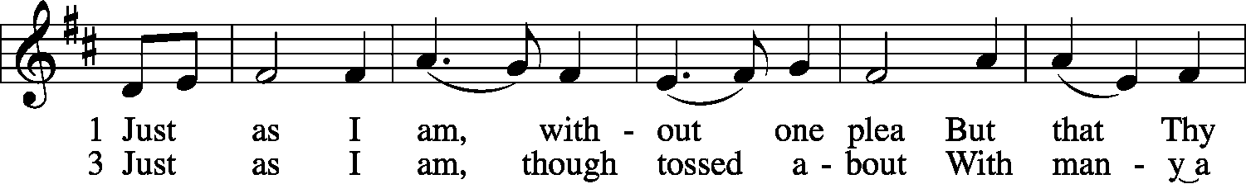
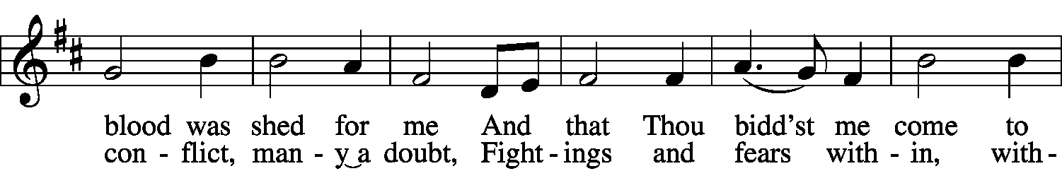
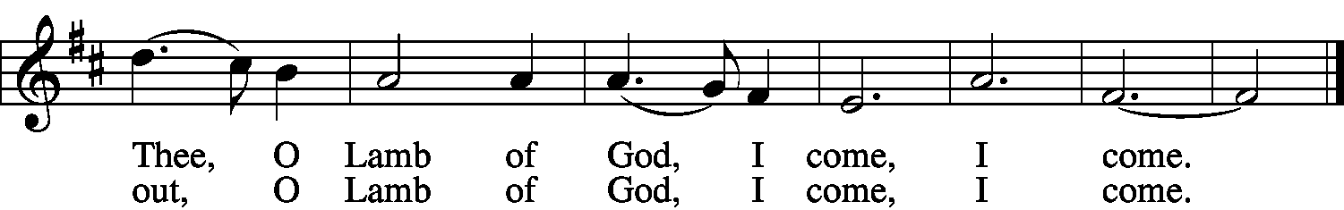

5 Just as I am, Thou wilt receive,
Wilt welcome, pardon, cleanse, relieve;
Because Thy promise I believe,
O Lamb of God, I come, I come.

Prayers of the Church based on Langston Hughes’ poem “Prayer [2]”
P: Gather up
in the arms of your mercy
C: The sick, the depraved
The desperate, the tired,
* Jesus reached out to people considered by others to be “scum”. We reach out to all people. And we ourselves may even feel like “scum” sometimes.
But look at how God responds with love.
P: All the scum
of our weary city.
Gather up
C: In the arms of your mercy.
P: Gather up
C: In the arms of your love—
P: Those who expect
C: No love from above.
P: For them—for us—
C: We pray now. Pastor then offers the Prayers of the Church

The Lord’s Prayer
P: Lord, remember us in Your kingdom, and teach us to pray:
All: Our Father who art in heaven, hallowed be Thy name, Thy kingdom come, Thy will be done on earth as it is in heaven. Give us this day our daily bread; and forgive us our trespasses as we forgive those who trespass against us; and lead us not into temptation, but deliver us from evil. For Thine is the kingdom and the power and the glory forever and ever. Amen.
Benediction (Blessing) Colossians 1:19-20
P: God was pleased to have all His fullness dwell in Jesus Christ, and through Him to reconcile to Himself all things, by making peace through His blood, shed on the cross. You are reconciled to God the Father, through the work of God the Son, and kept in this faith by God the Holy Spirit.
C: Amen.

Acknowledgements
This liturgy arranged and written by the Rev. Dr. Benjamin C. Squires. © 2019.
Portions adapted from Aaron Niequist’s songs and texts for A New Liturgy (Nos. 1, 2, & 3).
© Aaron Niequist. www.anewliturgy.com
“Absolution” adapted from LCMS World Relief Lenten Series, by Rev. Bernie Seter.
“Confession of Faith” by Rainsong/First Nations Version. © 2013 Rain Ministries, Inc. All Rights Reserved.
“Prayers of the Church” adapted from “Prayer [2]”, The Collected Poems of Langston Hughes. © 1994 Estate of L. Hughes.
Portions used by permission: LSB Hymn License .NET, no. 000013448.
Created by Lutheran Service Builder © 2006 Concordia Publishing House.
Unless otherwise indicated, all scripture quotations are from The Holy Bible, English Standard Version,
copyright © 2001 by Crossway Bibles, a division of Good News Publishers.
Used by permission. All rights reserved.

Service Continues
Closing Hymn My Song Is Love Unknown LSB 430 sts. 1–2, 5, 7
This hymn is inspired by Herbert’s “The Sacrifice,” especially stanza 7: “Never was a grief like Thine.”
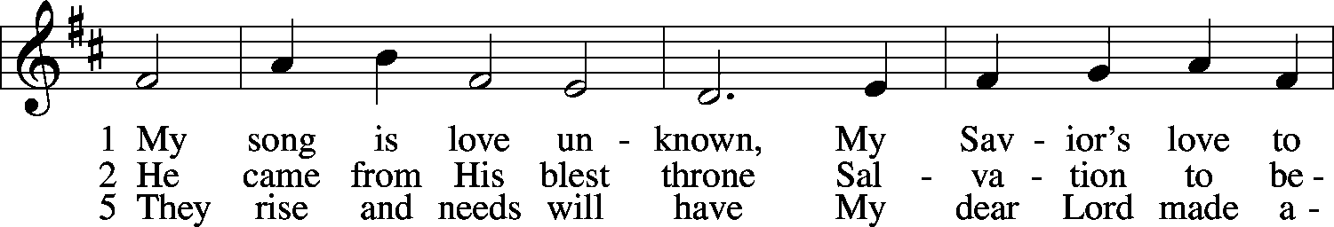
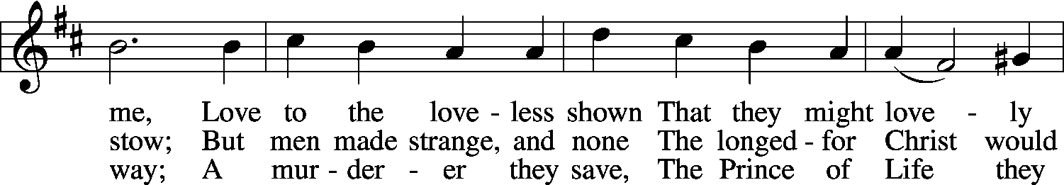
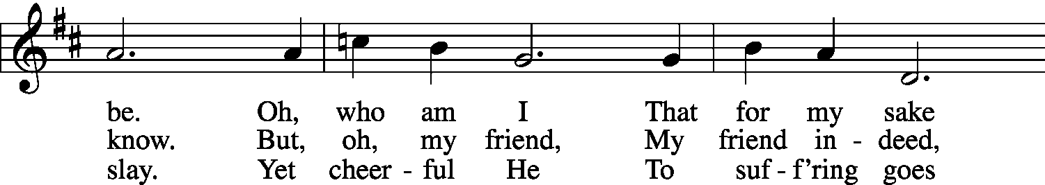
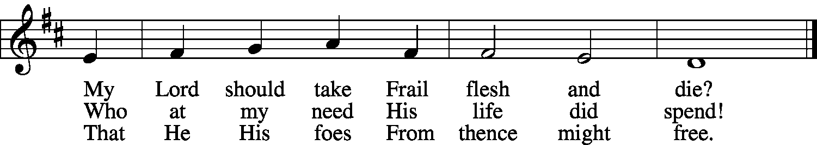

7 Here might I stay and sing,
No story so divine!
Never was love, dear King,
Never was grief like Thine.
This is my friend,
In whose sweet praise
I all my days
Could gladly spend!
© John Ireland Trust. Used by permission: LSB Hymn License .NET, no. 100013448.

Announcements

