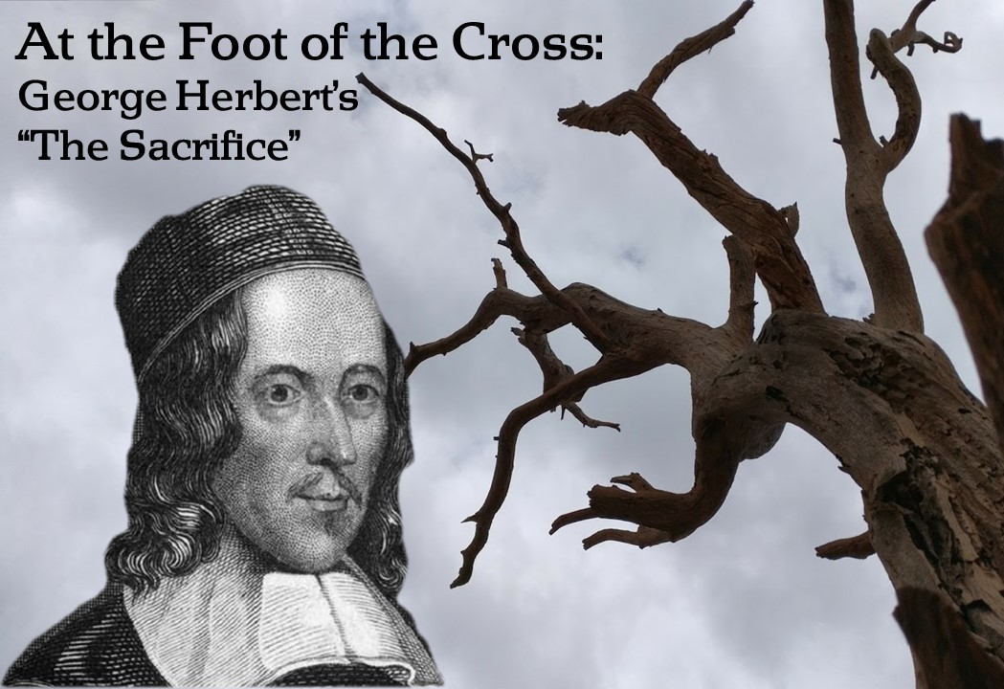
Wednesday, April 10, 2019

Bethel Lutheran Church & Preschool
5110 Grand Avenue, Gurnee, Illinois 60031 – (847) 244-9647
Pastor Ben Squires
Cell phone: 224-419-5519 or email: pastor@bethelgurnee.org
Katrina Johns, Equipping Coordinator
Direct line: 224-623-0800 or email: katrina@bethelgurnee.org
Website: www.BethelGurnee.org

Worship Schedule
Sundays 8:00 a.m. & 10:45 a.m.
Holy Communion: 1st, 3rd, 5th Sunday of the month
Becky Lanzito & Karen Leicht - Organists, Ann Souza - Music Director,
Mandi Diver – Choir/New Music Accompanist
___________________________________________________________________________________________________________________________________________________________________________________________________________________________________________________________________________________________________________________________________________________________________________________________
Welcome to our Visitors
We are pleased you chose to be with us in worship today, and pray the Lord blesses you as he has blessed us with your presence. Our goal is to help people find the right place for them to hear God’s word and serve His mission. We’d love to support you in that spiritual journey. Please take a moment to complete an attendance card and place it in the Offering plate or give to an usher. This card will help us connect with you.
Holy Communion
The Lord’s Supper is celebrated according to the Lutheran Confessions based on the teaching Jesus gave his disciples and us that he is truly present in this meal. Confident that our sins are forgiven, we experience our oneness with him and each other as he gathers us at his table. His true body and blood, given and shed for us, we share in this meal as he invites in Matthew 26:26-28, “Take and eat; this is My Body … This is My Blood…” Baptized Christians sharing these beliefs are invited to receive Communion. All others are invited to the altar rail for a blessing. Wine can be taken by common chalice, individual cup, or by dipping your wafer into the chalice. Please address questions to the Elders or the Pastor. Non-alcoholic wine is in purple-colored cups.
Nursery
We have two rooms available for your use. When the service is in the sanctuary, the nursery is down the hall just past the restrooms. If the service is held in the gym, the nursery is in the youth room at the far end of the gym.
___________________________________________________________________________________________________________________________________________________________________________________________________________________________________________________________________________________________________________________________________________________________________________________________
Serving Today

Elder: Mike Bandman
Asst Elder: OPEN
Acolyte: Jeremy Leicht
Ushers: OPEN, OPEN
Lay Readers: Sue Bandman, Karen Kozlik
Greeters: Aaron Ratzburg Family

Hymn Practice
We are using this hymn on Good Friday, but it is not as familiar to us.
So tonight we will begin our time together by practicing singing this hymn.
When I Behold Jesus Christ LSB 542
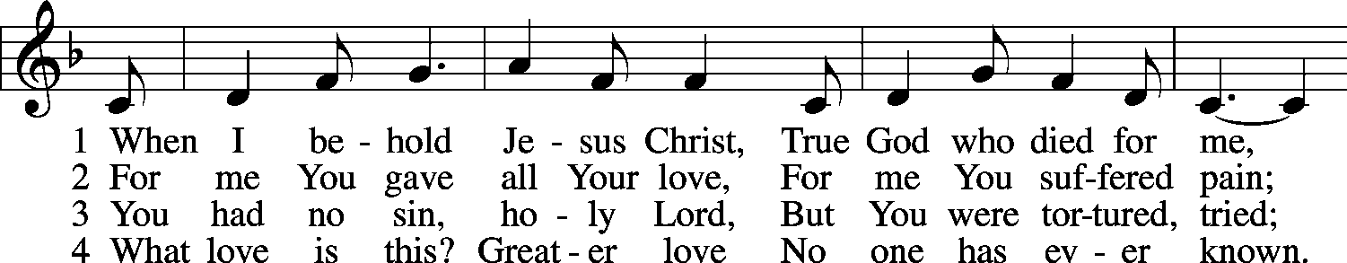
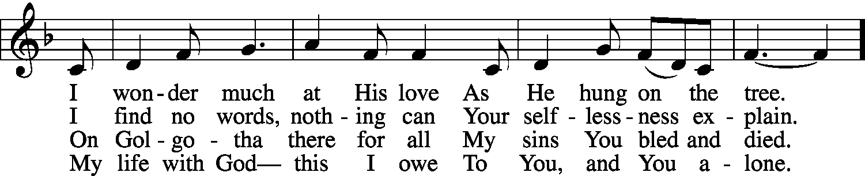
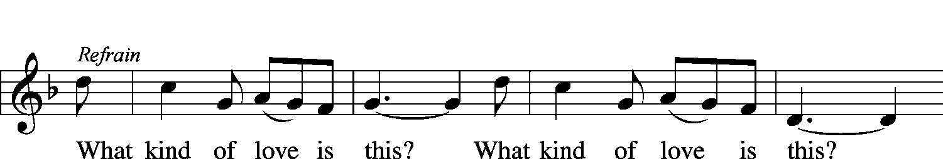
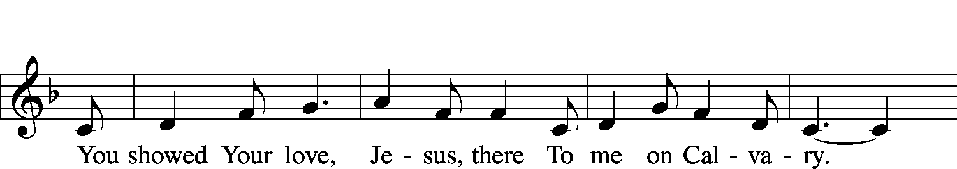
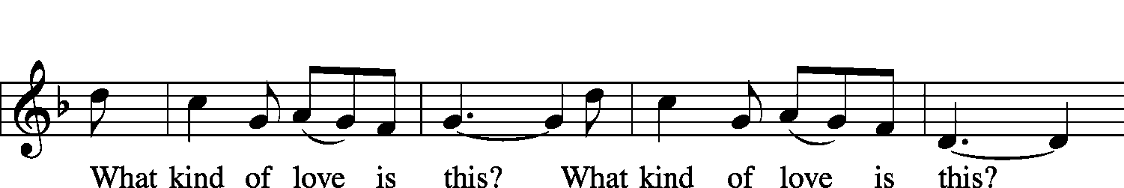
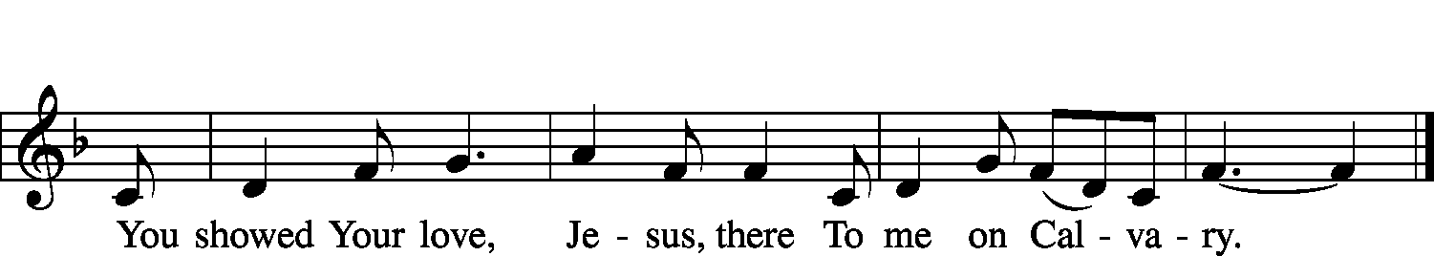
© 1998 Concordia Publishing House. Used by permission: LSB Hymn License .NET, no. 100013448.
© 1970 Ethiopian Evangelical Church Mekane Yesus. Used by permission: LSB Hymn License .NET, no. 100013448.
Evening Prayer
Adapted from the Lutheran Service Book Evening Prayer, this liturgy recalls
the Old Testament rhythm of prayer in the morning and the evening:
“When you lie down and when you arise” (Deuteronomy 6:7).
The liturgy of Evening Prayer, which grows out of the daily devotion of the home, has a simple, four-part outline: Service of Light, Psalmody, Readings and Responses, and Prayers.
The Service of Light began as a daily lamp-lighting service at the setting of the sun in the early centuries before gas or electric lights. The image of light in the midst of darkness is easily associated with Christ who is our light (John 1:9). We look forward to the day when we will no longer need lamp nor sun, for the Lord God will be our light (Revelation 22:5).

Opening Hymn Jesus, Refuge of the Weary LSB 423
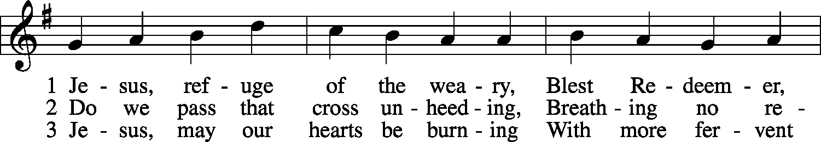
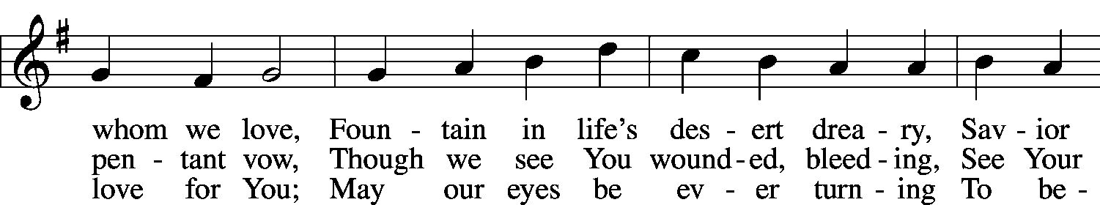
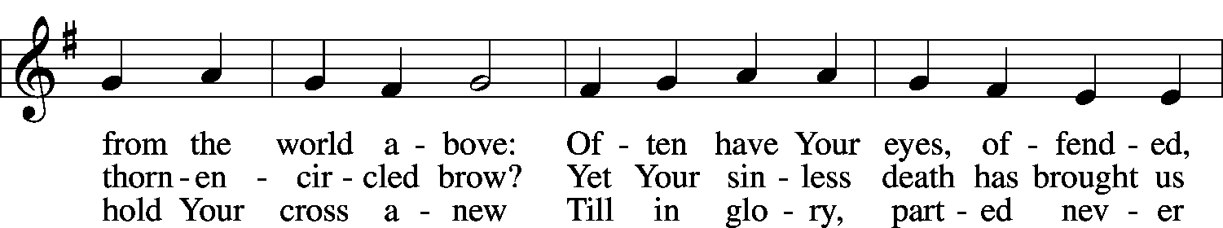
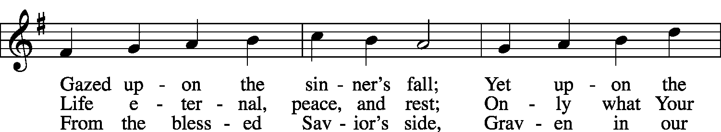
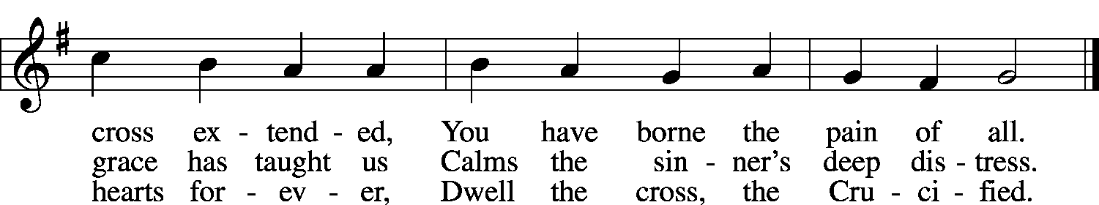
Opening Words
P: The Lord Almighty grant us a quiet night and peace at the last.
C: Amen.
P: It is good to give thanks to the Lord,
C: to sing praise to Your Name, O Most High;
P: to herald Your love in the morning,
C: Your truth at the close of the day.
Confession and Forgiveness
(Silence for reflection on the sins that trouble us).

Pastor: We begin with me confessing my sin…I confess to God Almighty, before the whole company of heaven and to you, my brothers and sisters, that I have sinned in thought, word, and deed by my fault, by my own fault, by my own most grievous fault; wherefore I pray God Almighty to have mercy on me, forgive me all my sins, and bring me to everlasting life. Amen.
C: The almighty and merciful Lord grant you
pardon, forgiveness, and remission of all your sins.
P: I thank my heavenly Father for this Good News. Amen.
C: I confess to God Almighty, before the whole company of heaven and to you, my brothers and sisters, that I have sinned in thought, word, and deed by my fault, by my own fault, by my own most grievous fault; wherefore I pray God Almighty to have mercy on me, forgive me all my sins, and bring me to everlasting life. Amen.
P: The almighty and merciful Lord grant you
pardon, forgiveness, and remission of all your sins.
C: I thank my heavenly Father for this Good News. Amen.
Greeting and Collect (Prayer of the Day)
P: The Lord be with you.
C: And also with you.
P: Let us pray. Almighty God, by Your great goodness mercifully look upon Your people that we may be governed and preserved evermore in body and soul; through Jesus Christ, Your Son, our Lord, who lives and reigns with You and the Holy Spirit, one God, now and forever.
C: Amen.

Gospel Reading for Tonight’s “Sacrifice” Stanzas (ESV)
²⁷Then the soldiers of the governor took Jesus into the governor’s headquarters, and they gathered the whole battalion before him. ²⁸And they stripped him and put a scarlet robe on him, ²⁹and twisting together a crown of thorns, they put it on his head and put a reed in his right hand. And kneeling before him, they mocked him, saying, “Hail, King of the Jews!” ³⁰And they spit on him and took the reed and struck him on the head.
Matthew 27:27–30
⁴Pilate went out again and said to [the crowd], “See, I am bringing him out to you that you may know that I find no guilt in him.” ⁵So Jesus came out, wearing the crown of thorns and the purple robe. Pilate said to them, “Behold the man!”
John 19:4–5
²³But they were urgent, demanding with loud cries that he should be crucified. And their voices prevailed. ²⁴So Pilate decided that their demand should be granted.
Luke 23:23–24
P: This is the Gospel of the Lord. C: Thanks be to God.
Readings for Other References in Tonight’s “Sacrifice” Stanzas (ESV)
Matthew 26:51–54
⁵¹ [Back in the Garden when Jesus was arrested]: behold, one of [the disciples] who were with Jesus stretched out his hand and drew his sword and struck the servant of the high priest and cut off his ear. ⁵²Then Jesus said to him, “Put your sword back into its place. For all who take the sword will perish by the sword. ⁵³Do you think that I cannot appeal to my Father, and he will at once send me more than twelve legions of angels? ⁵⁴But how then should the Scriptures be fulfilled, that it must be so?”
Isaiah 5:1–4
¹Let me sing for my beloved, my love song concerning his vineyard:
My beloved had a vineyard on a very fertile hill.
²He dug it and cleared it of stones, and planted it with choice vines;
he built a watchtower in the midst of it, and hewed out a wine vat in it;
and he looked for it to yield grapes,
but it yielded wild grapes.
³And now, O inhabitants of Jerusalem and men of Judah,
judge between me and my vineyard.
⁴What more was there to do for my vineyard, that I have not done in it?
When I looked for it to yield grapes, why did it yield wild grapes?
John 15:1–6
¹[Jesus said:] “I am the true vine, and my Father is the vinedresser. ²Every branch of mine that does not bear fruit he takes away, and every branch that does bear fruit he prunes, that it may bear more fruit. ³Already you are clean because of the word that I have spoken to you. ⁴Abide in me, and I in you. As the branch cannot bear fruit by itself, unless it abides in the vine, neither can you, unless you abide in me. ⁵I am the vine; you are the branches. Whoever abides in me and I in him, he it is that bears much fruit, for apart from me you can do nothing. ⁶If anyone does not abide in me he is thrown away like a branch and withers; and the branches are gathered, thrown into the fire, and burned.”
Genesis 3:17–19
¹⁷And [after they had sinned, God said to Adam],
“Because you have listened to the voice of your wife
and have eaten of the tree of which I commanded you,
‘You shall not eat of it,’
cursed is the ground because of you;
in pain you shall eat of it all the days of your life;
¹⁸thorns and thistles it shall bring forth for you;
and you shall eat the plants of the field.
¹⁹By the sweat of your face you shall eat bread,
till you return to the ground,
for out of it you were taken;
for you are dust, and to dust you shall return.”
1 Peter 1:10–12
¹⁰Concerning this salvation, the prophets who prophesied about the grace that was to be yours searched and inquired carefully, ¹¹inquiring what person or time the Spirit of Christ in them was indicating when he predicted the sufferings of Christ and the subsequent glories. ¹²It was revealed to them that they were serving not themselves but you, in the things that have now been announced to you through those who preached the good news to you by the Holy Spirit sent from heaven, things into which angels long to look.
L: This is the Word of the Lord.
C: Thanks be to God.

Hymn of the Day You Are the Way; through You Alone LSB 526
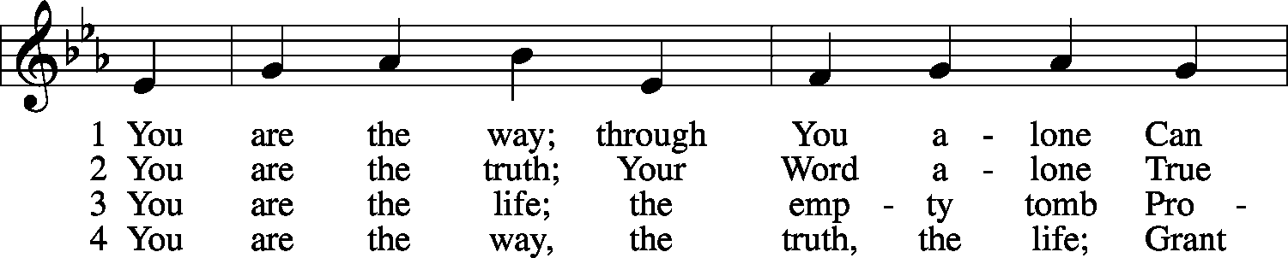
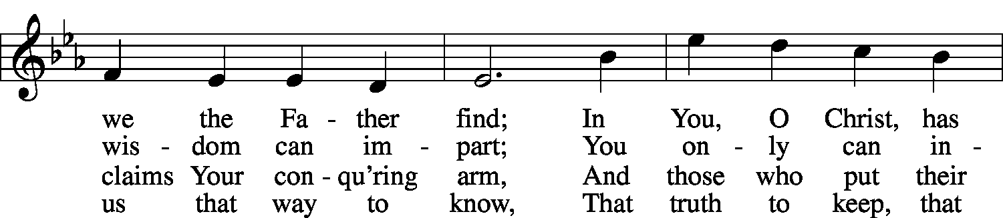
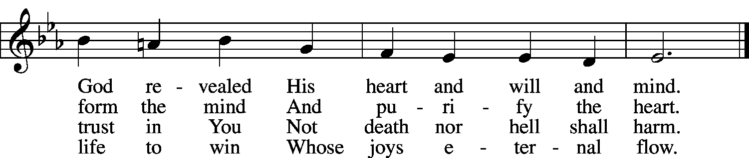

Sermon I, Who Am Truth, Turn Into Truth Their Deeds
(see handout)
Offering
Offertory God, Who Made the Earth and Heaven LSB 877, sts. 1,3
(we join in singing as the offerings are brought forward to the altar) 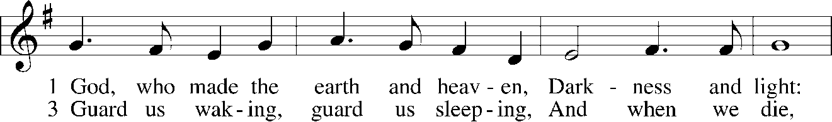
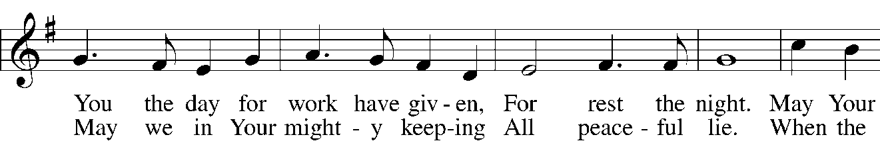
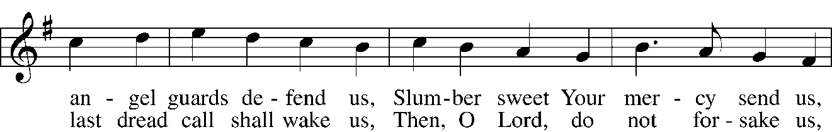
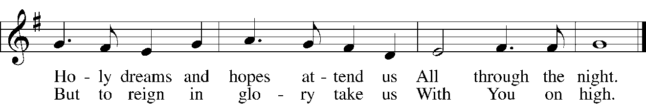
Prayers of the Church
P: Hear my prayer, O Lord;
C: Listen to my cry.
P: Keep me as the apple of Your eye;
C: Hide me in the shadow of Your wings.
P: In righteousness I shall see You;
C: When I awake, Your presence will give me joy.
P: Be present, merciful God, and protect us through the hours of this night, so that we who are wearied by the changes and chances of life may find our rest in You; through Jesus Christ, our Lord. C: Amen.
P: Visit our dwellings, O Lord, and drive from them all the snares of the enemy; let Your holy angels dwell with us to preserve us in peace; and let Your blessing be on us always; through Jesus Christ, our Lord. C: Amen.
P: Gracious Lord, we give You thanks for the day, especially for the good we were permitted to give and to receive; the day is now past and we commit it to You. We entrust to You the night; we rest in surety, for You are our help, and You neither slumber nor sleep. C: Amen.

(Silence for meditation)

The Lord’s Prayer
P: Lord, remember us in Your kingdom, and teach us to pray:
All: Our Father who art in heaven, hallowed be Thy name, Thy kingdom come, Thy will be done on earth as it is in heaven. Give us this day our daily bread; and forgive us our trespasses as we forgive those who trespass against us; and lead us not into temptation, but deliver us from evil. For Thine is the kingdom and the power and the glory forever and ever. Amen.
Benediction
P: Guide us waking, O Lord,
C: and guard us sleeping,
P: That awake we may watch with Christ
C: and asleep we may rest in peace.
P: The almighty and merciful Lord,
the Father, the Son, and the Holy Spirit, bless you and keep you. C: Amen.

Closing Hymn When I Survey the Wondrous Cross LSB 425
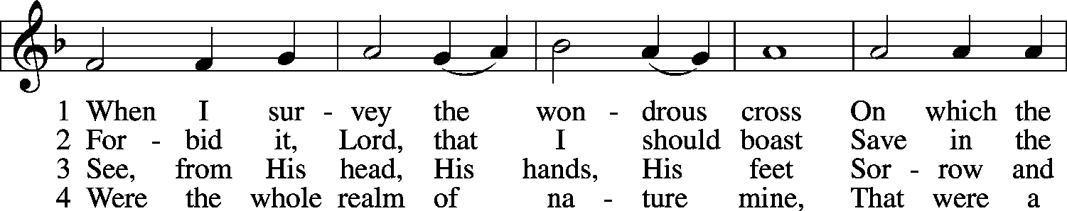
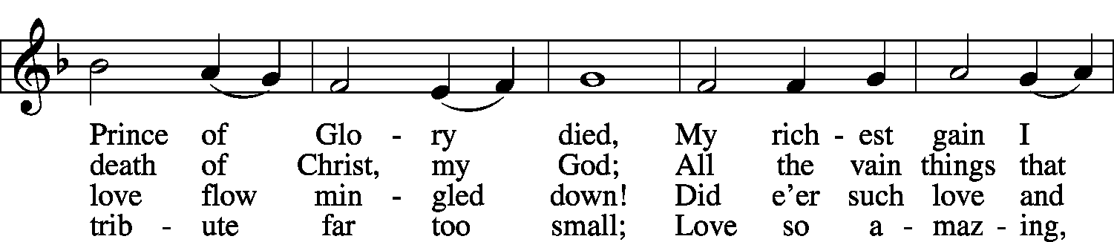
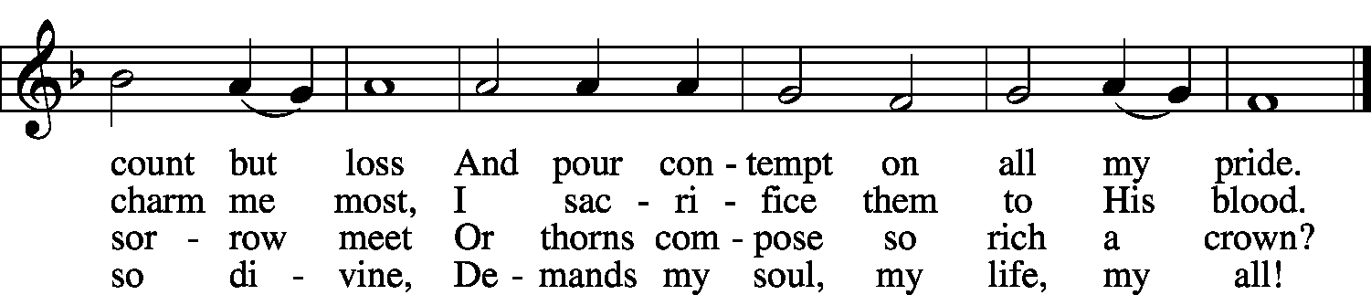
Announcements

Easter Breakfast

The Bethel Youth and Families,
cordially invite you
to food and fellowship Easter Sunday, April 21.

We will have breakfast casseroles, pancakes, pastries,
fresh fruit, coffee, tea, juices, & water.

Come worship with us and make the Bethel Breakfast a part of your day. There will be 2 breakfast sittings to choose from:
7:00 a.m.—8:00 a.m. & 9:00 a.m.—10:30 a.m.

Please see the Hub for a reservation form
which can be placed in the offering plate
or dropped in the church office!!!

There is a donation board for menu items and
a help needed board in the back of church. Please sign up!

Palm Sunday
April 14 ~ 8:00 a.m. & 10:45 a.m.
Worship with communion in the gym.
Maundy Thursday
April 18 ~ 6:30 p.m.
Worship with communion in the sanctuary.
Good Friday
April 19 ~ 1:00 p.m. & 6:30 p.m.
Worship in the sanctuary.
Easter Sunday
April 21
Sunrise 6:00 a.m.
Worship with communion in sanctuary.
Festival Services 8:00 a.m. & 10:45 a.m.
Worship with communion in the gym.

Acknowledgments
Adapted from “Evening Prayer” in Lutheran Service Book.
Used by permission: LSB Hymn License .NET, no. 000013448.
Created by Lutheran Service Builder © 2006 Concordia Publishing House.
Scripture quotations in the liturgy are from
The Holy Bible, English Standard Version,
copyright © 2001 by Crossway Bibles, a division of Good News Publishers.

