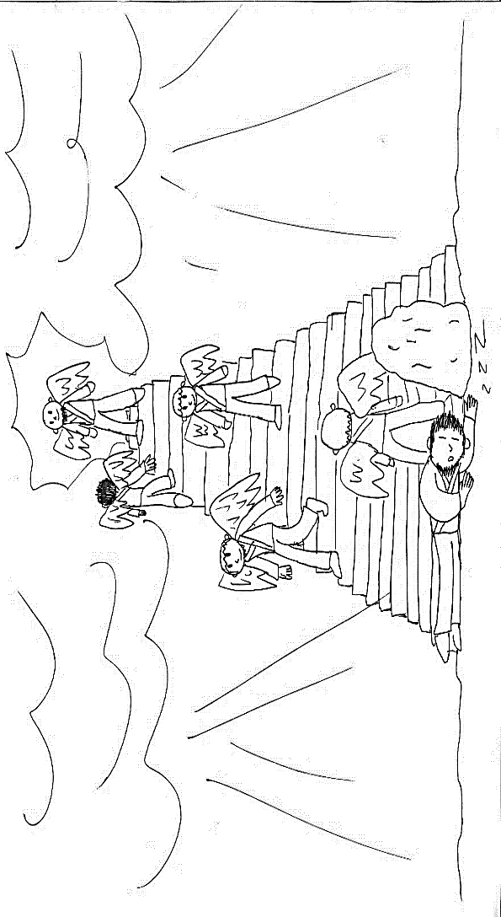
Week 4: June 21/24
Jacob’s Dream – Genesis 27-28
Pages 36-37 in Know the Bible Now

Step 1: reread the story covered in the sermon
Step 2: read and discuss the following questions:
- Read Genesis 27 to see the circumstances surrounding Jacob’s journey to Haran. Is the true purpose of his journey merely to find a wife? How might this context help us understand God’s promise to “be with...keep...and bring [Jacob] back” to the land?
- How do the promises of God made to Jacob in this story compare to the promises made to Abraham in last week’s story (Genesis 18 & 21)? How are they related?
- Jesus references this story in John 1:51 and identifies himself as the ladder linking heaven and earth. What is the significance of this? (Keep in mind the promise to Jacob that “in you and your offspring shall all the families of the earth be blessed.”)
- God told Jacob some amazing and wonderful things in his dream. What have you dreamt that you hope will come true (or what have you dreamt that did come true?)?
- Look at the words to the old hymn “Nearer My God To Thee” and reflect on how this can also be seen as a prayer.

Step 3: Read the Did You Know? questions on the page under the picture. How much of this information was new to you? What struck you and could impact your view of the world this week?

Step 4: Write down a phrase or thought from this story that will encourage you this week as a disciple (follower of Jesus).

**image courtesy of Sam Squires

