Week 5: June 28/July 1
Moses & the Plagues – Exodus 5-10
Pages 60-61 in Know the Bible Now
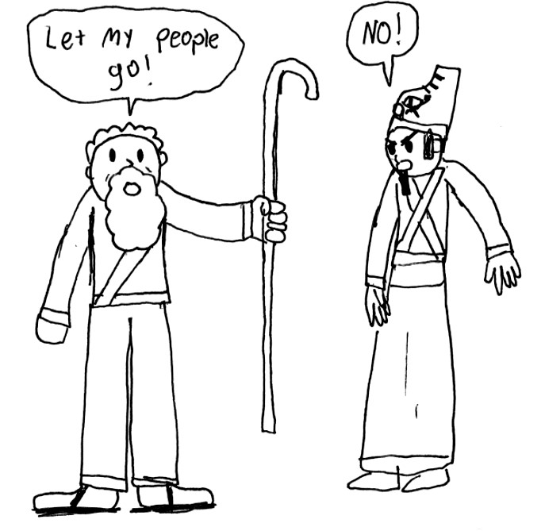

Step 1: reread the story covered in the sermon
Step 2: read and discuss the following questions:
- Pharaoh’s hardened heart can be a thorny issue to work through. Throughout the text we see that:
  - The Lord hardened Pharaoh’s heart (Exodus 4:21, 7:3, 9:12, 10:1, 10:20, 10:27, 11:10, 14:14, 14:8)
  - Pharaoh’s heart “was hardened” (Exodus 7:13, 7:14, 7:22, 8:19, 9:7, 9:35, 14:5)
  - Pharaoh hardened his own heart (Exodus 8:15, 8:32, 9:34)

- What does this say about Pharaoh’s (and our own) responsibility?
- What does this say about God’s sovereignty?
- We know that God is light and in Him is no darkness at all (1 John 1:5), that He cannot be tempted by evil or tempt anyone (James 1:13), and that He is not the author of confusion (1 Corinthians 14:13), so God is in no way the author of evil. How then does this fit with the concept of God hardening Pharaoh’s heart? (cf. Exodus 9:16, Exodus 10:1-2, Romans 9:14-23.)

- Ra—the sun god—was the main deity and father of the gods of ancient Egypt. With this in mind, what might the significance be of the ninth plague (darkness over the Egyptians but not over the Hebrews)?

- Read Exodus 12 (or pg. 62 of Know the Bible Now) to see how God’s people--those identified with the blood of a spotless lamb--were delivered on the first Passover from the final plague (death). Centuries later, during another Passover, the true spotless lamb would be sacrificed, and his blood would, once and for all, deliver God’s people from death.

- What parallels do you see between this story and today’s society?
Step 3: Read the Did You Know? questions on the page under the picture. How much of this information was new to you? What struck you and could impact your view of the world this week?
Step 4: Write down a phrase or thought from this story that will encourage you this week as a disciple (follower of Jesus).
**image courtesy of Sam Squires

